**RAVFS**

**Req’d Services**

**Analysis Class Report**

***Revision History***

|  |  |  |  |  |
| --- | --- | --- | --- | --- |
| **Authors** | **Description of Change** | **Sections** | **Rev** | **Date** |
| Samantha, Francisco | Initial creation of document and creation of classes | 2.1 | 1 | Feb 25, 2019 |
| Vincent | added claim methods | 2.2.7 | 2 | Feb 27, 2019 |
| Rene | added request methods | 2.2.6 | 2 | Feb 27, 2019 |
| Rene | added descriptions | 2.2.2-.7 |  | Mar 6, 2019 |
| Samantha | Uploaded class diagram | 2.1 | 3 | Mar 11, 2019 |

**Table of Contents**

Team Description **4**

Project Description **4**

Analysis Class Diagram 5

Analysis Class List 6

Account 6

Tenant 6

Landlord 7

Location 7

Service Provider 8

Request 9

Claim 9

# Team Description

|  |  |
| --- | --- |
| **Team Member Name** | **Email Address** |
| Samantha Montoya | sammontoya@csu.fullerton.edu |
| Rene Ortiz | ror5446@csu.fullerton.edu |
| Anthony Goossens | yorkii@csu.fullerton.edu |
| Francisco Daniel | fpdaniel2@csu.fullerton.edu |
| Vincent Bravinder | bravinderv@csu.fullerton.edu |

# Project Description

Statement of Purpose:

Provide automation platform for a tenant landlord interaction, particularly in regards to tenants requesting services from maintenance providers.

Detailed Description:

A platform that allows for tenants to request a service provider, they will be asked what kind of service they need and then a series of questions that categorizes the urgency of the request. Landlords will be able to look at requests at their leisure, and can approve or deny the request. If a request is denied the tenant will need to pay for the service.

The platform will also contact the appropriate service provider, if the request is an emergency, or the landlord has approved the request. The service provider can insert a claim showing cost of service. The landlord will be able to pay this claim, or direct the tenant to pay the claim.

## Analysis Class Diagram

<https://www.lucidchart.com/invitations/accept/93391fa4-325c-4edb-abfe-9c03193bd1d7>

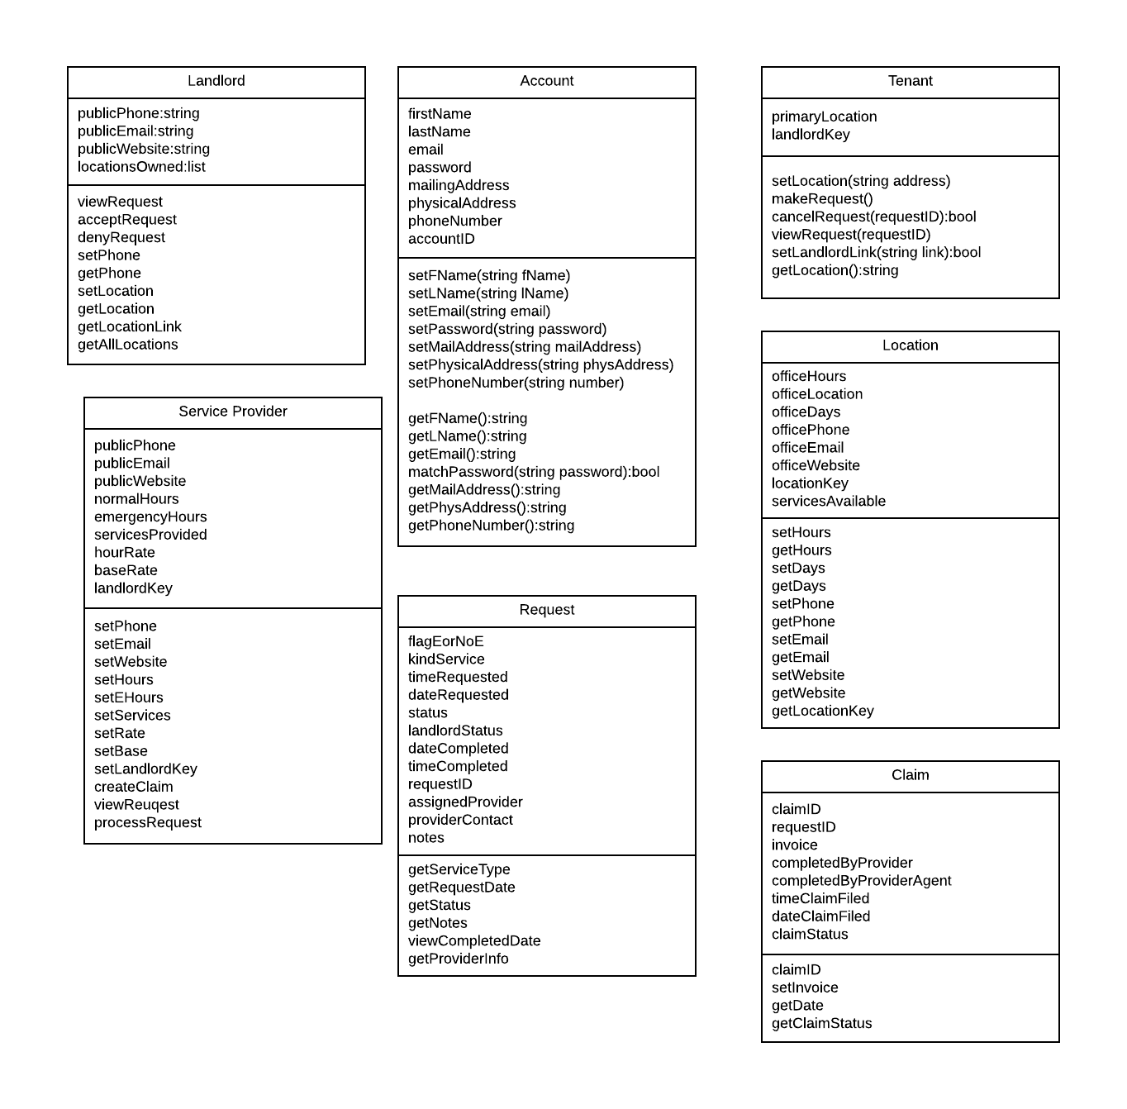

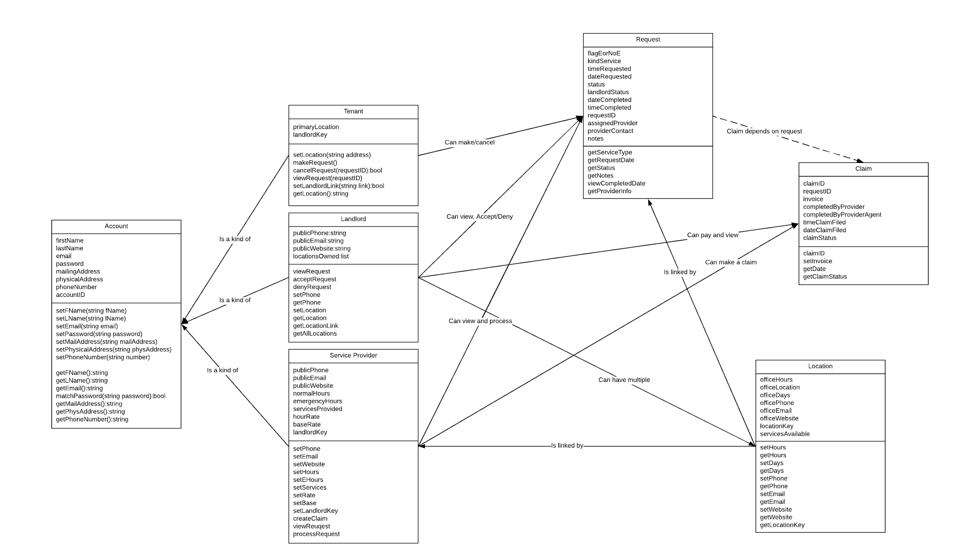

## Analysis Class List

|  |  |
| --- | --- |
| **Sequence Number** | **Analysis Class** |
| 1 | Account |
| 2 | Tenant |
| 3 | Landlord |
| 4 | Service Provider |
| 5 | Request |
| 6 | Claim |
|  |  |

### Account

Description: A parent class for Tenant, Landlord, and Service Provider that contains methods and attributes common to all three of them. This contains methods and attributes focused on managing account information that is applicable to each child account type.

Methods:

* setFName
* setLName
* setEmail
* setPassword
* setMailingAddress
* setPhysicalAddress
* setPhoneNumber
* getFName
* getLName
* getEmail
* matchPassword
* getMailingAddress
* getPhysicalAddress
* getPhoneNumber

Attributes:

* First Name
* Last Name
* email
* password
* mailing address
* physical address
* phone number
* account ID

### Tenant

Description: A class for a user that contains methods and attributes in common with the landlord. It contains methods and attributes focused on service requests and location.

Methods:

* setLocation
* getLocation
* makeRequest
* cancelRequest
* viewRequest
* setLandlordLink

Attributes:

* Primary location
* Landlord link key

### Landlord

Description: A class that contains methods and attributes for requests and location. It contains methods focused on location information and tenant requests.

Methods:

* viewRequest
* acceptRequest
* denyRequest
* setPhone
* getPhone
* setLocation
* getLocation
* getLocationLink
* getAllLocations
* removeLink

Attributes:

* Public phone
* public email
* public website
* locationsOwned

### Location

Description: A class that contains methods and attributes for location (apartment complex) information. It focuses on location information associated with landlord and tenants.

Methods:

* setHours
* getHours
* setDays
* getDays
* setPhone
* getPhone
* setEmail
* getEmail
* setWebsite
* getWebsite
* getLocationKey

Attributes:

* office Location
* office hours
* office days
* office phone
* office email
* office website
* location key

### Service Provider

Description: A class that contains methods and attributes for service provider information. The class focuses on gathering and displaying service provider information.

Methods:

* setPhone
* getPhone
* setEmail
* getEmail
* setWebsite
* getWebsite
* setHours
* getHours
* setEHours
* getEHours
* setServices
* getServices
* setRate
* getRate
* setBase
* getBase
* setLandlordLocationKey
* createClaim
* viewRequest
* processRequest

Attributes:

* Public phone
* public email
* public website
* non-emergency work times
* emergency work times
* kinds of services can service
* hourly rate
* base rate
* land lord link key (can have multiple)

### Request

Description: A class that contains methods and attributes for a service request. It focuses on retrieving information on a tenant request.

Methods:

* getServiceType
* getRequestDate
* getStatus
* viewInitMessage
* getLPayStatus
* viewCompDate
* getProviderInfo
* getNotes

Attributes:

* Flag (non-emergency, emergency)
* kind of service
* time of request
* date of request
* status (waiting for landlord, waiting for service provider, completed, denied by landlord)
* notes
* date and time of completion (Viewed from claim)
* request ID
* Assigned to Service Provider
* Service Provider Contact:

### Claim

Description: A class that contains methods and attributes for a claim. The class focuses on displaying claim information for a completed request.

Methods:

* setClaimID
* setInvoice
* getDateAndTime
* getClaimStatus

Attributes:

* Claim ID and Request ID
* Invoice (Price of service)
* Completed by Service Provider Name (Ex. Bob’s Plumbing Co)
* Completed by service provider agent’s name (Billy Bob Jr)
* Date and Time completed
* Claim status (paid, unpaid)